WEEKEND WORKSHEET
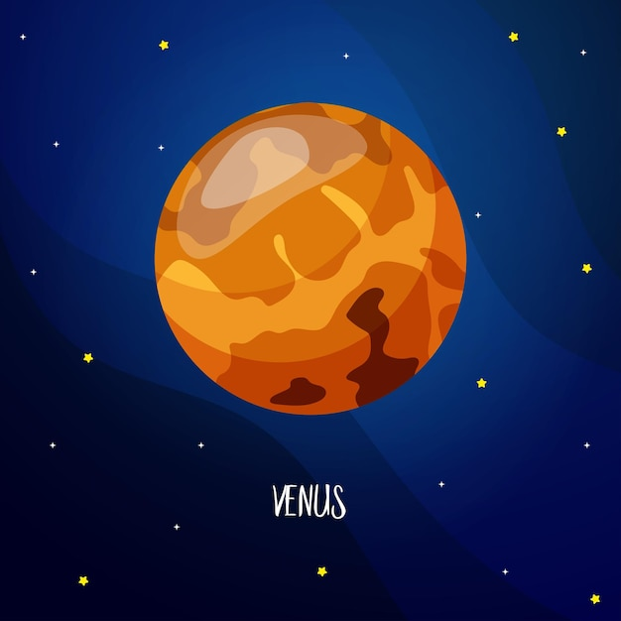

Venus is the second planet from the Sun and it is the brightest planet in our sky. It is sometimes called the Evening Star or the Morning Star because we can often see it at these times of day. The thick atmosphere, composed mostly of carbon dioxide and sulphuric acid clouds, reflects a significant amount of sunlight, making it appear exceptionally bright. Its orbit also brings it relatively close to Earth, enhancing its visibility. Venus is similar to Earth in size, mass and density but its atmosphere is very different. Its air has mostly carbon dioxide and it has a lot of clouds which make it the hottest planet in our solar system. The temperature on Venus is more than 450 degrees Celsius which is hotter than the surface of Mercury even though Mercury is closer to the Sun. We know a lot about Venus because many spacecraft have visited the planet the first one was Mariner 2 in 1962. It flew past Venus and took measurements of its atmosphere. Since then other spacecraft have landed on the surface of Venus and sent back information. But they only worked for a short time because the conditions are so difficult there. The Soviet Union's Venera 7 was the first spacecraft to land on another planet when it arrived on Venus in 1970. It sent back data for 23 minutes before it stopped working. The longest any spacecraft has survived on Venus is two hours and seven minutes. That was the American spacecraft Pioneer Venus Multiprobe in 1978.

Give answer to the following questions
  - The temperature on Venus is more than 450 degrees Celsius.
  - The mass and density of Venus is more than our Earth.
  - Its air has mostly carbon dioxide and it has a less of clouds
- Choose the option that is/are NOT correct:
  - Only I
  - I and III
  - Only II
  - II and III
- Statement: Many spacecrafts have landed on the surface of Venus and sent back information but they only worked for a short time.
Reason: The cool atmosphere of Venus made the conditions difficult for the spacecraft
Choose the correct option:

    - Statement is true and the reason is the correct explanation.
    - Statement is true but the reason is false.
    - Both the statement and reason are false.
    - Statement is false but the reason is true.
- Venus is the brightest planet in our sky. State the reason.
Ans- Venus is the brightest planet in our sky because he thick atmosphere, composed mostly of carbon dioxide and sulphuric acid clouds, reflects a significant amount of sunlight, making it appear exceptionally bright. Its orbit also brings it relatively close to Earth, enhancing its visibility

- Inspite of being the second planet why is Venus considered the hottest planet in our solar system?
Ans- Inspite of being the second planet Venus is considered the hottest planet in our solar system because its ts air has mostly carbon dioxide and it has a lot of clouds which make it the hottest planet in our solar system.
- Name the first spacecraft to visit Venus, and what did it do?
Ans- The spacecraft that visited the planet first was Mariner 2 in 1962.
It flew past Venus and took measurements of its atmosphere.

